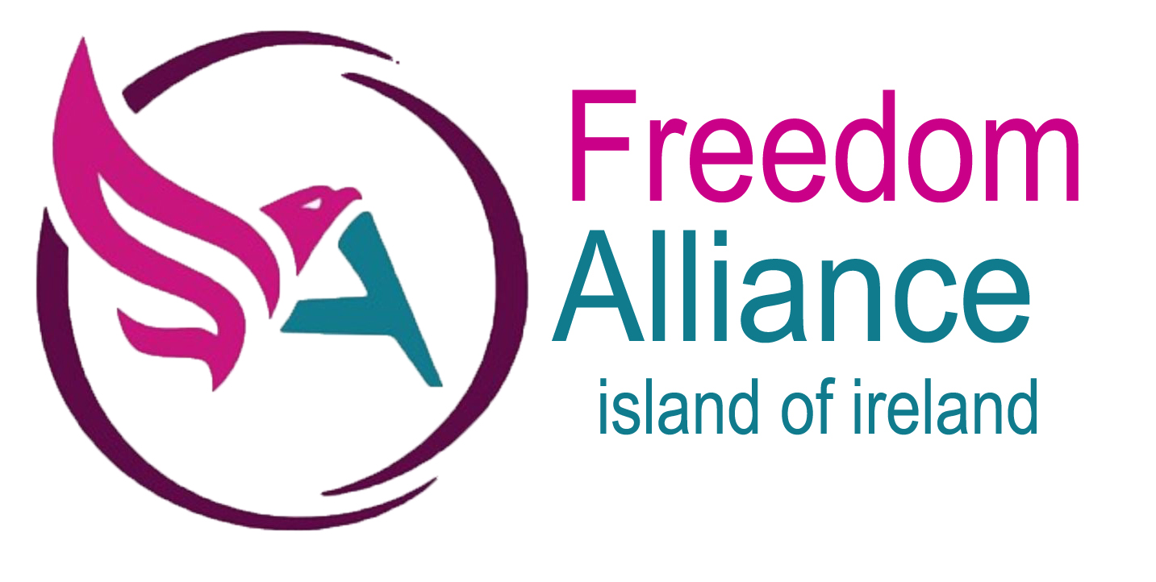

Business Name
Address

URGENT NOTICE
You are receiving this letter from a group, The Freedom Alliance. We are concerned about the implication of how the present government’s policies referring to the covid legislation, may affect business legally. The enforcement of the covid regulation are violating fundamental rights. This could potentially put business open to legal action if they try to enforce certain regulations.
There is a large question mark over whether the covid regulation have passed through the proper parliamentary procedure, and are even lawful under Common Law rights.
In imposing the regulation, little thought has been given to the legal ramifications of the liability. If an individual or company uses coercive means, or enforcement, for the requirement to be vaccinated before entry or employment. This leaves the individual or business open to prosecution for not complying with existing legislation if enforcing covid mandates.
The existing rights and legislation that is breached is as follows
Common Law and Human Rights
- The right to decline any medical intervention without any penalty.(1)
- The right to autonomy over their own body.(2)
- The right to full indemnity in the workplace for losses sustained from any requirement imposed on them by their employer.
- The right to respect for their private life.(3)
- The right not to suffer dismissal or detriment (4)for upholding and asserting their legal rights and bringing matters relating to alleged breach of legal obligations to the attention of their employer.
Data Protection Act
- The right to keep their medical records confidential. This includes (5)
- Vaccination status.
- Any clinical reason why they should not be vaccinated
- GDPR
The Equality Act 2010.(6)
- The requirement for staff or customers to be vaccinated, or suffer loss of entry or loss of employment, is discriminatory under the Equality Act 2010:

Liability
- Failing to provide full indemnity for any losses arising out of any serious adverse event arising from vaccination.
- Implicitly requiring them to give up their common law right to free and informed consent. (7)
- Implicitly requiring them to give up autonomy over their bodies.
Nuremburg Code

- The Covid-19 vaccinations are all currently in phase 3 of clinical trials (8)which are due to end at various points throughout 2022-23 dependent on the vaccine concerned, understandable given that some of the vaccines are using for the first time in humans mRNA (messenger RNA) and modRNA (nucleoside-modified messenger RNA) technology. Notwithstanding the emergency use authorisation for the administration of these experimental medications, the Government is only underwriting the manufacturers of these experimental medications against any liability arising from their administration.
- The Nuremburg code clearly states (9)– The voluntary consent of the human subject is absolutely essential. This means that the person involved should have legal capacity to give consent; should be so situated as to be able to exercise free power of choice, without the intervention of any element of force, fraud, deceit, duress, overreaching, or other ulterior form of constraint or coercion; and should have sufficient knowledge and comprehension of the elements of the subject matter involved as to enable him to make an understanding and enlightened decision. This latter element requires that before the acceptance of an affirmative decision by the experimental subject there should be made known to him the nature, duration, and purpose of the experiment; the method and means by which it is to be conducted; all inconveniences and hazards reasonably to be expected; and the effects upon his health or person which may possibly come from his participation in the experiment.
The duty and responsibility for ascertaining the quality of the consent rests
upon each individual who initiates, directs, or engages in the experiment. It is a personal duty and responsibility which may not be delegated to another with
impunity.

The government do not have the legislative jurisdiction to enact laws that remove rights. Instead they are using coercive means, to use the jurisdiction that business have over property and employment to enforce mandates. This could potentially hold a business or individual liable for and or privately liable for and or civilly and or criminally liable for participating in unlawful, illegal and or criminal activity and or for supporting crimes against humanity, and or failing to prevent acts so defined, including but not limited to acts that are purposely committed as part of a widespread and or systematic policy, directed against living men and women, and in particular in your case, BUSINESS, committed in furtherance of government policy.
Before BUSINESS NAME makes vaccine mandates compulsory, for employment or entry. We are asking businesses to write to the Justice Minister, Naomi Long, asking for immunity from prosecution for violation of rights and legislation breached by the Corona Virus regulations and indemnity from liability for vaccine damage and imposing government guidelines.
It would be prudent not to enforce any government instruction concerning covid until proof of exemption has been provided. If confronted by a government agent you have the choice to refuse any Fixed Penalty Notice and exercise your Right to go to court.
Text highlighted in blue are hyperlink evidence of the statements to the websites and documents. We would like you to fill in the details below and send this letter to the address of the justice minister enclosed. Do not enforce any covid restriction until confirmation of exemption from liability has been received.
Thank you for your time
Freedom Alliance (10)
Island of Ireland
You will find links to the evidence by visiting freedomallianceioi.com/links

Naomi Long
Department of Justice
BUSINESS NAME
Address

Date
Block B
Castle Buildings
Stormont Estate
Belfast
Northern Ireland
BT4 3SG

FAO Naomi Long
I am writing to you with reference the covid19 regulations. Particularly in connection with the vaccine mandates being imposed on business. These regulation violate the fundamental rights of the individual and several regulation there to protect these rights. The legislation that is being mandated infringe upon, are the Nuremberg Code, Data Protection and the Equality Act 2010 and or Discrimination Act 1995 NI. We as a business can also be liable for damages caused by the vaccination of our employees and customers through enforcement or coercion.
Before I can enforce any of the regulation within our business, I will need confirmation that we will be immune from prosecution for any breaches of the regulation that are infringed upon, for the enforcing of the covid19 vaccine mandate. We will also need indemnity from any legal action for enforcement of the vaccine and any adverse side effects caused by the administration of the vaccine serum.
The rights of the individual that are being breached.
Common Law and Human Rights
- The right to decline any medical intervention without any penalty.(1)
- The right to autonomy over their own body.(2)
- The right to full indemnity in the workplace for losses sustained from any requirement imposed on them by their employer.
- The right to respect for their private life.(3)
- The right not to suffer dismissal or detriment (4)for upholding and asserting their legal rights and bringing matters relating to alleged breach of legal obligations to the attention of their employer.
Data Protection Act
- The right to keep their medical records confidential. This includes: (5)
- Vaccination status.
- Any clinical reason why they should not be vaccinated
The Equality Act 2010.(6)
- The requirement for staff or customers to be vaccinated, or suffer loss of entry or loss of employment, is discriminatory under the Equality Act 2010:

Liability
- Failing to provide full indemnity for any losses arising out of any serious adverse event arising from vaccination.
- Implicitly requiring them to give up their common law right to free and informed consent. (7)
- Implicitly requiring them to give up autonomy over their bodies.
Nuremburg Code

- The Covid-19 vaccinations are all currently in phase 3 of clinical trials (8)which are due to end at various points throughout 2022-23 dependent on the vaccine concerned, understandable given that some of the vaccines are using for the first time in humans mRNA (messenger RNA) and modRNA (nucleoside-modified messenger RNA) technology. Notwithstanding the emergency use authorisation for the administration of these experimental medications, the Government is only underwriting the manufacturers of these experimental medications against any liability arising from their administration.
- The Nuremburg code clearly states (9)– The voluntary consent of the human subject is absolutely essential. This means that the person involved should have legal capacity to give consent; should be so situated as to be able to exercise free power of choice, without the intervention of any element of force, fraud, deceit, duress, overreaching, or other ulterior form of constraint or coercion; and should have sufficient knowledge and comprehension of the elements of the subject matter involved as to enable him to make an understanding and enlightened decision. This latter element requires that before the acceptance of an affirmative decision by the experimental subject there should be made known to him the nature, duration, and purpose of the experiment; the method and means by which it is to be conducted; all inconveniences and hazards reasonably to be expected; and the effects upon his health or person which may possibly come from his participation in the experiment.
The duty and responsibility for ascertaining the quality of the consent rests
upon each individual who initiates, directs, or engages in the experiment. It is a personal duty and responsibility which may not be delegated to another with
impunity.

I request under the freedom of information act for the following information.
- Evidence to prove that the coronavirus legislation has been through the proper parliamentary procedure, and is enforceable legislation.
- Evidence to prove that the government has the legislative jurisdiction to write legislation that is in direct conflict with our inalienable rights.
I will also require a confirmation that I will be exempt from prosecution for the following legislation. This must be signed by and person with the authority to allow exemptions from prosecution that can be used in a court of law.
- Nuremburg Code – Violation - we are asking our customers and employees to enter a medical trial by force or coercion. This contravenes article one of the Nuremburg Code.
- Data Protection – Violation - we are asking customers and employees personal medical information that they do not have to give under data protection act.
- Equality Act – Violation - we are discriminating against an individual for a medical condition which contravenes the Equality Act 2010 and or Discrimination Act 1995 NI.
- Liability – We require full indemnity against legal action taken for the violation of the above legislation and for any medical condition that may arise after the administration of the Covid19 vaccination.

BUSINESS NAME will not be enforcing any covid19 regulation until we have received confirmation of full indemnity from any form of legal action caused by the imposing of these regulation.
Please respond within 14 days to the above address.
Yours sincerely

Name
Position
BUSINESS NAME
You will find links to the evidence by visiting freedomallianceioi.com

